Implement programs for estimating & eliminating trend in time series data- aggregation, smoothing
EX:No.5
DATE:29/03/25

AIM:
Write a program to implement programs for estimating & eliminating trend in time series data- aggregation, smoothing

ALGORITHM:
Step 1: Install required libraries (if not already installed).
Step 2: Import necessary libraries (pandas, numpy, matplotlib).
Step 3: Load air pollution data, parse dates, and set 'date' as the index.
Step 4: Remove duplicate timestamps and fill missing values.
Step 5: Select the 'pollution_today' column.
Step 6: Remove outliers using the IQR method.
Step 7: Ensure daily data frequency.
Step 8: Resample to weekly average (optional, not used in the plot).
Step 9: Create a figure and plot daily pollution levels as a line graph.
Step 10: Set labels, title, and legend for the plot.
Step 11: Show the plot.

CODE:

import numpy as np
import pandas as pd
import matplotlib.pyplot as plt
from statsmodels.tsa.holtwinters import SimpleExpSmoothing
# Load the time series data
file_path = r"C:\Users\HARISH\Downloads\accident_time_series_1000_rows.csv"

accident_df = pd.read_csv(file_path, parse_dates=["Date"], index_col="Date")
# Verify column names
if "Total Accidents" not in accident_df.columns:
raise ValueError("Column 'Total Accidents' not found in dataset. Check column names.")
# Select the "Total Accidents" column
time_series = accident_df["Total Accidents"].dropna()
### --- Trend Estimation Using Moving Average ---
window_size = 12 # 12-month moving average
moving_avg = time_series.rolling(window=window_size, center=True).mean()
# Detrended data (subtract moving average)
detrended_ma = time_series - moving_avg
### --- Trend Estimation Using Exponential Smoothing ---
alpha = 0.3 # Smoothing factor
exp_smooth = SimpleExpSmoothing(time_series).fit(smoothing_level=alpha, optimized=False)
smoothed_series = exp_smooth.fittedvalues
# Detrended data (subtract smoothed trend)
detrended_exp = time_series - smoothed_series
### --- Plot Original & Moving Average Trend ---
plt.figure(figsize=(12, 5))
plt.plot(time_series, label="Original Time Series", alpha=0.5)
plt.plot(moving_avg, label=f"{window_size}-month Moving Average", color="red", linestyle="dashed")
plt.xlabel("Date")
plt.ylabel("Total Accidents")
plt.title("Trend Estimation using Moving Average")
plt.legend()
plt.grid(True)
plt.show()
### --- Plot Detrended Data (Moving Average) ---
plt.figure(figsize=(12, 5))
plt.plot(detrended_ma, label="Detrended Data (Moving Average)", color="green")
plt.xlabel("Date")
plt.ylabel("Detrended Total Accidents")
plt.title("Time Series after Trend Removal (Moving Average)")
plt.legend()
plt.grid(True)

plt.show()
### --- Plot Original & Exponential Smoothing Trend ---
plt.figure(figsize=(12, 5))
plt.plot(time_series, label="Original Time Series", alpha=0.5)
plt.plot(smoothed_series, label="Exponentially Smoothed Trend", color="red", linestyle="dashed")
plt.xlabel("Date")
plt.ylabel("Total Accidents")
plt.title("Trend Estimation using Exponential Smoothing")
plt.legend()
plt.grid(True)
plt.show()
### --- Plot Detrended Data (Exponential Smoothing) ---
plt.figure(figsize=(12, 5))
plt.plot(detrended_exp, label="Detrended Data (Exp. Smoothing)", color="purple")
plt.xlabel("Date")
plt.ylabel("Detrended Total Accidents")
plt.title("Time Series after Trend Removal (Exponential Smoothing)")
plt.legend()
plt.grid(True)
plt.show()

OUTPUT:

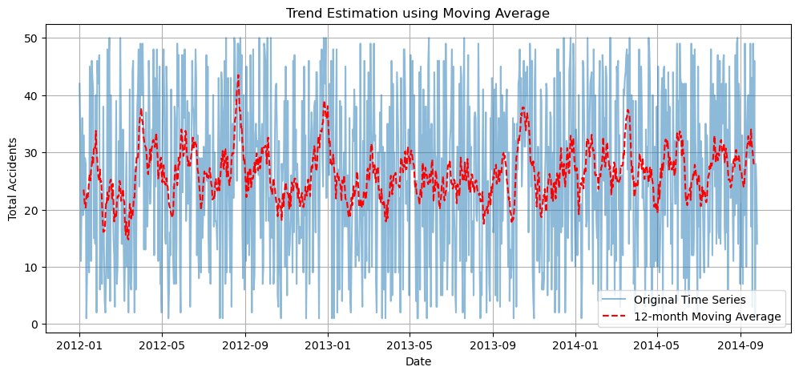

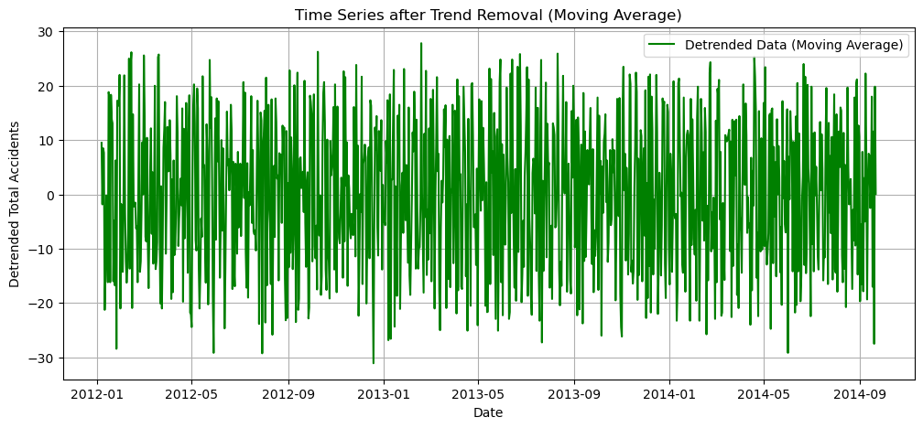

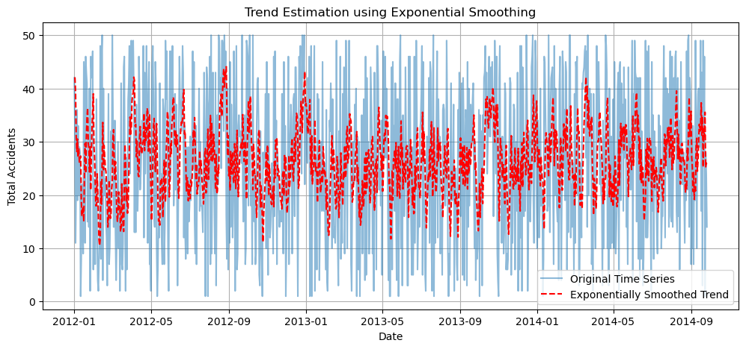

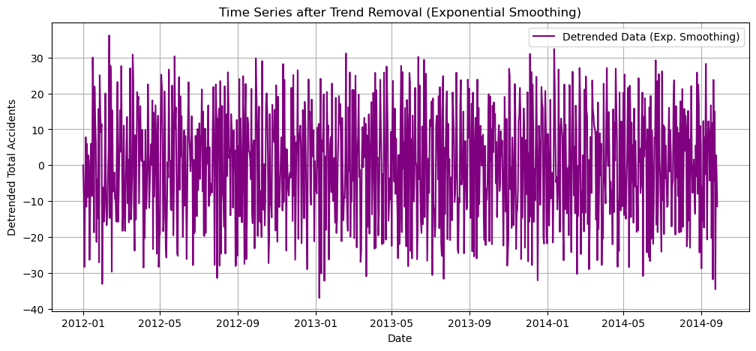
RESULT:
Thus, the program using the time series data implementation has been done successfully.

